**Experiment 1**

PART A

(PART A: TO BE REFFERED BY THE STUDENTS)

**Aim:** **To examine and access Data**

**Learning Outcomes: Learner should be able to**

1. Apply SAS programming to examine the data provided and prepare basic codes related to it
2. Carry out basic error handling.
3. Create library to access data and import data of different types

**Prerequisite:** Basics of SAS Programming

**Activity 1**

**Code 1**

data mycars;

set sashelp.cars;

AvgMPG=mean(mpg_city, mpg_highway);

run;

title "Cars with Average MPG Over 35";

proc print data=mycars;

var make model type avgmpg;

where AvgMPG > 35;

run;

title "Average MPG by Car Type";

proc means data=mycars mean min max maxdec=1;

var avgmpg;

class type;

run;

title;

1. View the above code. How many steps are in the program?
2. How many statements are in the PROC PRINT step?
3. How many global statements are in the program?
4. Run the program and view the log.
5. How many observations were read by the PROC PRINT step?
6. How many observation have avgmpg<30?

**Activity 2**

**Code 2**

data canadashoes set sashelp.shoes;

where region="Canada;

Profit=Sales-Returns; run;

prc print data=canadashoes;

**run;**

1. Format the above program to improve the spacing. What syntax error is detected? Fix the error and run the program.
2. Read the log and identify any additional syntax *; errors or warnings. Correct the program and format the code again?
3. Add a comment to describe the changes that you made to the program.
4. Run the program and examine the log and results. How many rows are in the canadashoes data?

**Activity 3**

1. Create a table work.P1 and Read airline data within sashelp library and determine how many observation air >115?

**Activity 4**

1. Write a PROC CONTENTS step to generate a report of the STORM_SUMMARY.SAS7BDAT table properties. Highlight the step and run only the selected.
2. How many observations are in the table?
3. How is the table sorted?

**Activity 5**

1. Complete the OPTIONS statement to ensure that the column names follow SAS naming conventions.

options ;

1. Complete the LIBNAME statement to create a library named NP that reads NP_INFO.XLSX in the data folder.

libname;

1. Highlight the OPTIONS and LIBNAME statements and run the selection.
2. Navigate to your list of libraries and open the NP library **(Paste the screenshot)**. Open each table and view the data.

**Activity 6**

1. Complete the PROC CONTENTS step to read the parks table in the NP library.

proc contents data= ;

run;

1. Complete the LIBNAME statement to clear the NP library.

libname ;

1. Run the program and examine the log. Which column names were modified to follow SAS naming conventions?

**Activity 7**

1. This program imports a tab-delimited file. Run the program twice and carefully read the log. What is different about the second submission?

*Modify the path if necessary;

proc import datafile="s:/workshop/data/storm_damage.tab"

dbms=tab out=storm_damage_tab;

run;

1. Fix the program and rerun it to confirm that the import is successful.

**Theory:**

**Please refer to the notes shared during the class.**

PART B

(PART B: TO BE COMPLETED BY STUDENTS)

**Paste the screenshot of code and the output for each sub-activity wherever applicable or type the answer.**

Students must submit the **PDF copy** as per following segments within four hours of the practical. The soft copy must be uploaded on the **Teams**. The filename should be **PS_batch_rollno_experimentno Example: PA_A_B001_Exp1**

|  |  |
| --- | --- |
| **Roll No.: A206** | **Name: Harsh Bapu Salunke** |
| **Prog./Yr/Sem: B Tech IT /II/IV** | **Batch: A OR B** |
| **Date of Experiment: 5 jan 2024** | **Date of Submission:** |

**Activity 1:**

**1)**

**2)**

**Activity 2:**

**Activity 3:**

**Activity 4:**

**1] ANS** 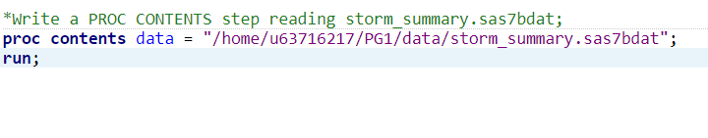

**OUTPUT :**

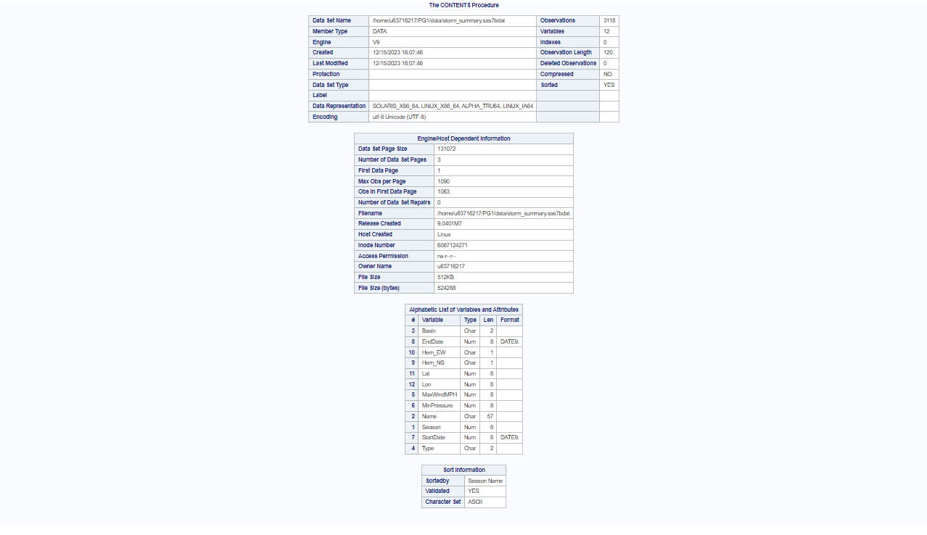

**4.2 ] 3118 observations**

**4.3 ] season name**

**Activity 5:**

**Activity 6:**

**Conclusion (Learning Outcomes):** Reflect on the activities performed by you and jot down your learnings about the topic.